EXPERIMENT 8: REPORT SCHEDULING, AUTOMATION AND ALERTS USING MICROSOFT POWER BI
1. Aim
To design and implement report scheduling, automated report delivery, and KPI alerts using Microsoft Power BI for effective business performance monitoring.
2. Software Requirements
- Microsoft Power BI Desktop
- Power BI Service
- Global Superstore Dataset
- Microsoft Excel
3. Theory
Power BI provides features for automated reporting and monitoring. Scheduled refresh updates datasets automatically, subscriptions deliver reports through email, and KPI alerts notify users when specific performance thresholds are crossed. These features help businesses monitor performance and take timely corrective actions.
4. Implementation and Procedure
Part A: Scheduled Reporting Plan
Three reports were planned:
- Daily Sales Report: Tracks daily sales and orders by region. It is delivered to regional managers at 7:30 AM after a 6:30 AM refresh.
- Weekly Profit Report: Monitors profit and profit margin by category and region. It is delivered to the finance team every Monday at 8:00 AM.
- Monthly Executive Dashboard: Displays major business KPIs and trends. It is delivered to executives on the first working day of each month at 9:00 AM.
- Top 10 Customers Report: Shows the highest-value customers and is shared weekly with the key account team.
A1. Refreshing the dataset before report delivery ensures that recipients receive updated and accurate information.
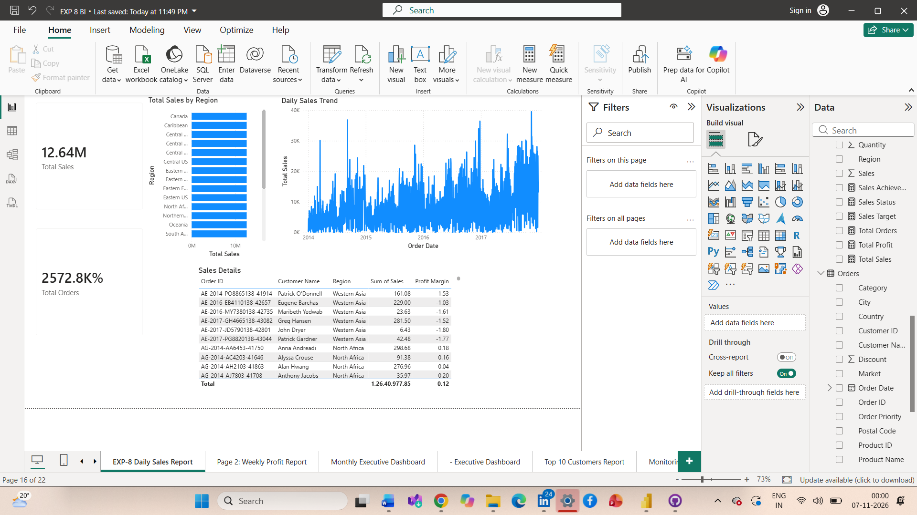
Part B: Distribution Strategy
Executives receive summarized dashboards, regional managers receive detailed sales reports, and the finance team receives profit and transaction reports. The key account team receives customer performance reports.
Executives receive the least detailed reports because they mainly need an overview, while finance teams require more detailed information for analysis.
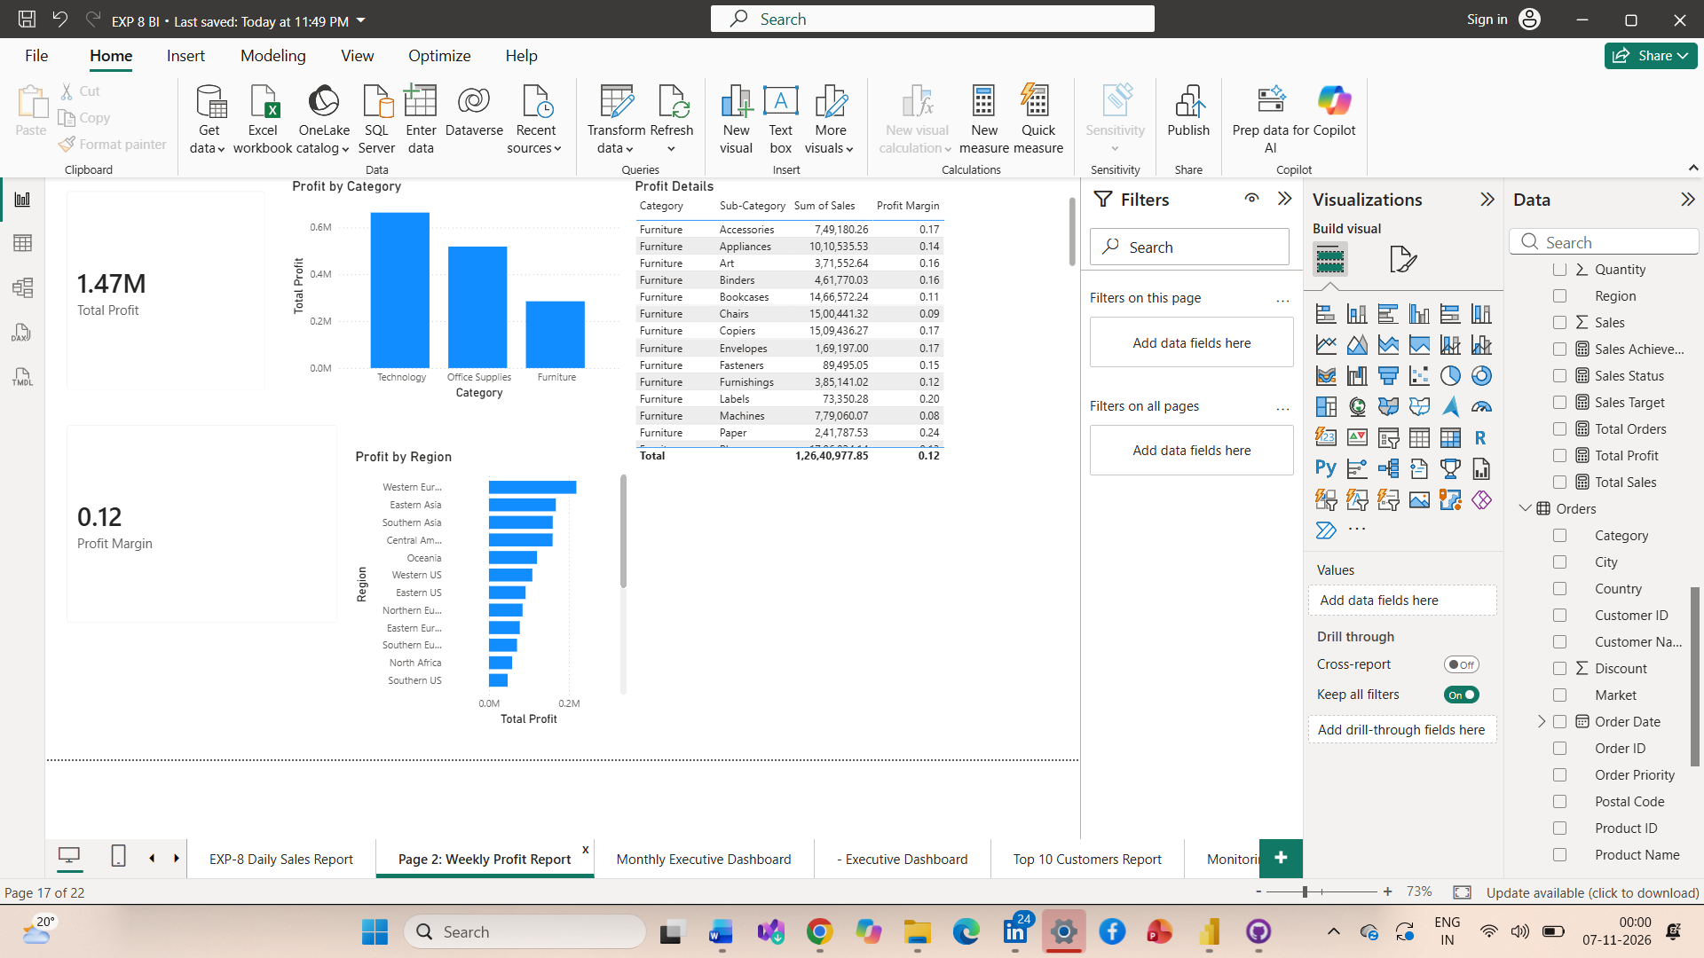
Part C: KPI Alerts Configuration
The following alerts were defined:
- Profit Margin: Alert when it falls below 10%.
- Sales Decline: Alert when year-over-year sales decrease by more than 15%.
- Return Rate: Alert when returns increase by more than 20%.
- Average Discount: Alert when the average discount exceeds 25%.
The following DAX measures support KPI monitoring:
Profit Margin % =
DIVIDE([Total Profit], [Total Sales])

Sales YoY % =
VAR PrevSales =
CALCULATE([Total Sales],
SAMEPERIODLASTYEAR(Dim_Date[Date]))
RETURN
DIVIDE([Total Sales] - PrevSales, PrevSales)

Returned Orders =
CALCULATE(
DISTINCTCOUNT(Orders[Order ID]),
Orders[Returned] = "Yes"
)

Return Rate % =
DIVIDE(
[Returned Orders],
DISTINCTCOUNT(Orders[Order ID])
)

Average Discount % =
AVERAGE(Orders[Discount])
Note: Adapt table and column names to match the existing Power BI model.
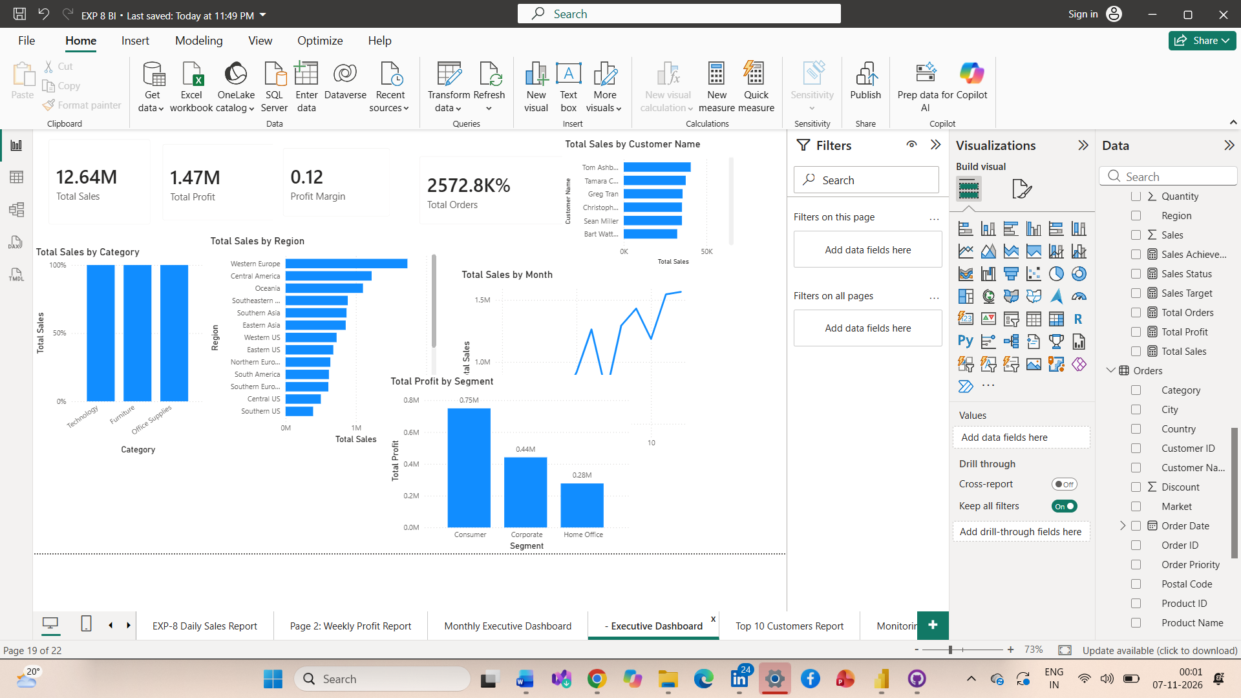
Part D: Report Design
Five report pages were prepared:
- Daily Sales Report: Total Sales, Total Orders, Sales by Region, daily sales trend, and transaction details.
- Weekly Profit Report: Total Profit, Profit Margin, Profit by Region, and Profit by Category.
- Monthly Executive Dashboard: Total Sales, Total Profit, Total Orders, Profit Margin, regional sales, and monthly sales trend.
- Top 10 Customers Report: Top customers by sales, customer details, and sales by segment.
- Monitoring Dashboard: Profit Margin, Sales YoY, Return Rate Change, Profit by Region, and Total Sales by Year.
Part E: Power BI Service Configuration
The report was prepared for publishing to Power BI Service. The planned configuration includes:
- Publish the report from Power BI Desktop.
- Configure daily dataset refresh at 6:30 AM.
- Enable refresh failure notifications.
- Pin KPI cards and regional profit charts to the executive dashboard.
- Configure alerts for profit margin, sales decline, and return rate.
- Set up email subscriptions for relevant users.
- 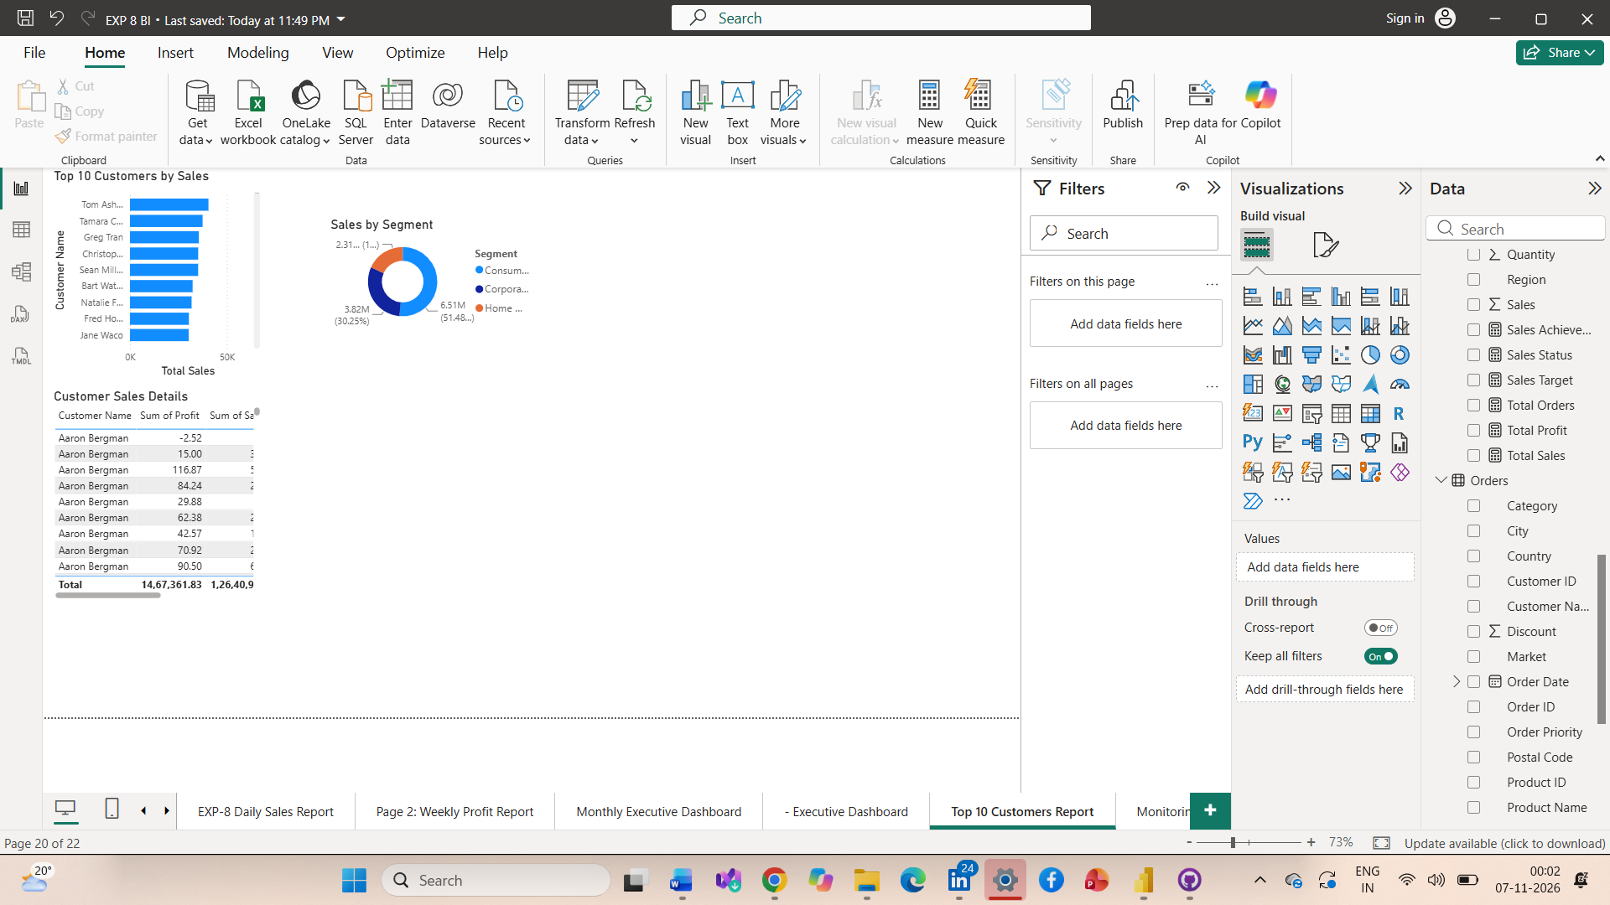
5. Monitoring and Recommendations
The business scenario indicates that sales are increasing while profitability is not improving at the expected rate.
Possible causes include excessive discounts, increased operating costs, and low-profit product categories.
Recommended actions:
- Review discount policies.
- Identify low-profit products and regions.
- Investigate high return rates.
- Monitor profit margins weekly.
- Share automated reports with responsible managers.
- Review KPI alerts and take corrective action promptly.
6. Observations
- Scheduled refresh helps maintain updated reports.
- Email subscriptions simplify report distribution.
- KPI alerts help identify performance problems.
- Profit Margin requires a DAX measure for accurate monitoring.
- Sales reports provide detailed information, while executive dashboards provide a business overview.
Actual refresh duration, alert results, and publishing status should be recorded after testing in Power BI Service.
7. Result
The report scheduling plan, distribution strategy, KPI alert definitions, and monitoring dashboard were designed using Microsoft Power BI to support automated business reporting and performance monitoring.
8. Learning Outcomes
- Learned how to plan scheduled report delivery.
- Understood how to configure KPI alerts and DAX measures.
- Learned how automated reporting supports business decision-making.
9. References
- Microsoft Power BI Documentation
- Global Superstore Dataset
- Microsoft Learn: Power BI Service and Dashboard Alerts

